Interfaces in Kotlin

An "interface object" can refer to
a specific type of object in object-oriented programming that acts as a contract, defining a set of methods a class must implement without providing the implementation details.

Restaurant/Menu Example with Many Branches/Locations

Interface is the Menu which is Contract (What we can make for you?)
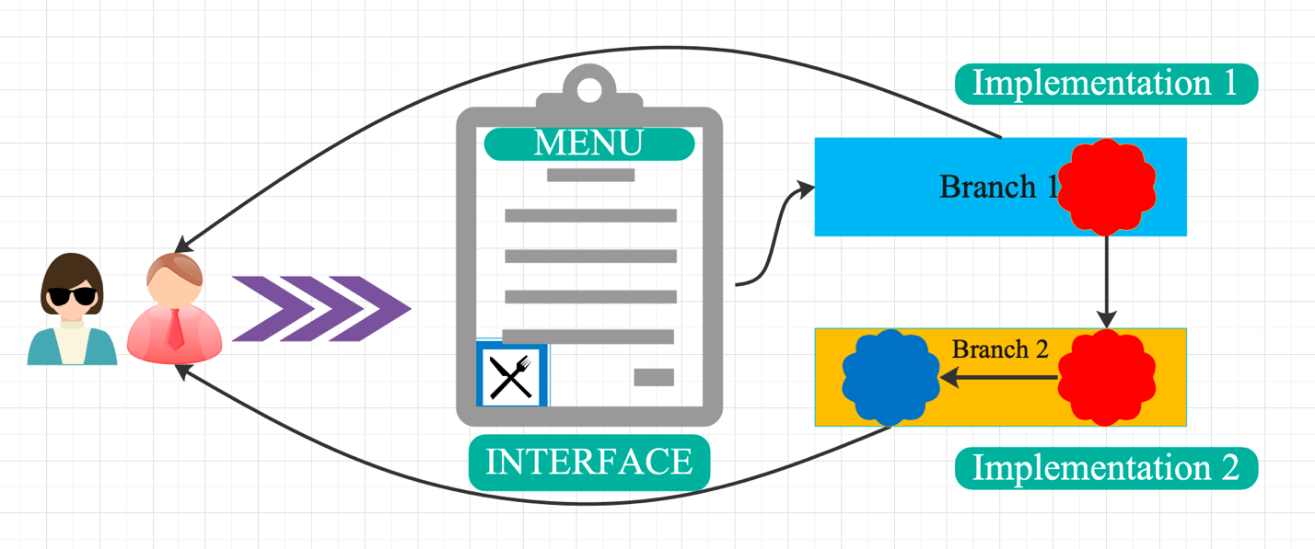

Here is a clean Kotlin design that adds a method to the Music interface which:
✔ Returns total playing time in seconds
✔ Uses Double
✔ Works for both singles and albums
✔ Fully abstracts the concept of duration

interface Music {
val title: String
val artist: String

fun play()
fun getInfo(): String
}

Updated Music Interface

interface Music {
val title: String
val artist: String

fun play()
fun getInfo(): String

// Required method: total duration in seconds as Double
fun getDurationSeconds(): Double
}

Implementing in a Song

data class Song(
override val title: String,
override val artist: String,
val durationSeconds: Double
) : Music {

override fun play() {
println("Playing song: $title by $artist")
}

override fun getInfo(): String {
return "Song: $title by $artist ($durationSeconds sec)"
}

override fun getDurationSeconds(): Double {
return durationSeconds
}
}

Implementing in an Album
data class Album(
override val title: String,
override val artist: String,
val songs: List<Song>
) : Music {

override fun play() {
println("Playing album: $title by $artist")
}

override fun getInfo(): String {
return "Album: $title by $artist with ${songs.size} tracks"
}

override fun getDurationSeconds(): Double {
return songs.sumOf { it.getDurationSeconds() }
}
}

getAllSongs: Returns List<Song> containing all songs. Provides uniform access to tracks regardless of format.

Implementation for a Song

data class Song(
override val title: String,
override val artist: String,
val durationSeconds: Double
) : Music {

override fun play() {
println("Playing song: $title by $artist")
}

override fun getInfo(): String {
return "Song: $title by $artist ($durationSeconds sec)"
}

override fun getDurationSeconds(): Double {
return durationSeconds
}

override fun getAllSongs(): List<Song> {
return listOf(this)
}
}

Implementation for an Album

data class Album(
override val title: String,
override val artist: String,
val songs: List<Song>
) : Music {

override fun play() {
println("Playing album: $title by $artist")
}

override fun getInfo(): String {
return "Album: $title by $artist (${songs.size} tracks)"
}

override fun getDurationSeconds(): Double {
return songs.sumOf { it.getDurationSeconds() }
}

override fun getAllSongs(): List<Song> {
return songs
}
}

How this design works

Single (Song)
getAllSongs() → returns [this]

Album
getAllSongs() → returns its entire track list
This allows you to write generic code like:
fun printSongTitles(music: Music) {
music.getAllSongs().forEach { println(it.title) }
}
It works perfectly with both songs and albums, which is the purpose of the abstraction.

University Project

Refactoring

// Define a common interface for menu handlers
interface MenuHandler {
fun handle()
}

fun main() {

// Anonymous class for Menu Item 1
val handler1 = object : MenuHandler {
override fun handle() {
println("Handling Menu Item 1")
}
}

// Anonymous class for Menu Item 2
val handler2 = object : MenuHandler {
override fun handle() {
println("Handling Menu Item 2")
}
}

// Anonymous class for Menu Item 3
val handler3 = object : MenuHandler {
override fun handle() {
println("Handling Menu Item 3")
}
}

// Simulate menu selection
val menuChoice = 2

// Use when statement to dispatch to the correct handler
when (menuChoice) {
1 -> handler1.handle()
2 -> handler2.handle()
3 -> handler3.handle()
else -> println("Invalid choice")
}
}

Using Lambda Functions

fun main() {
// Lambda handlers for menu items
val handler1: () -> Unit = { println("Handling Menu Item 1") }
val handler2: () -> Unit = { println("Handling Menu Item 2") }
val handler3: () -> Unit = { println("Handling Menu Item 3") }

// Simulate menu selection
val menuChoice = 2

// Dispatch to the correct handler using when
when (menuChoice) {
1 -> handler1()
2 -> handler2()
3 -> handler3()
else -> println("Invalid choice")
}
}

